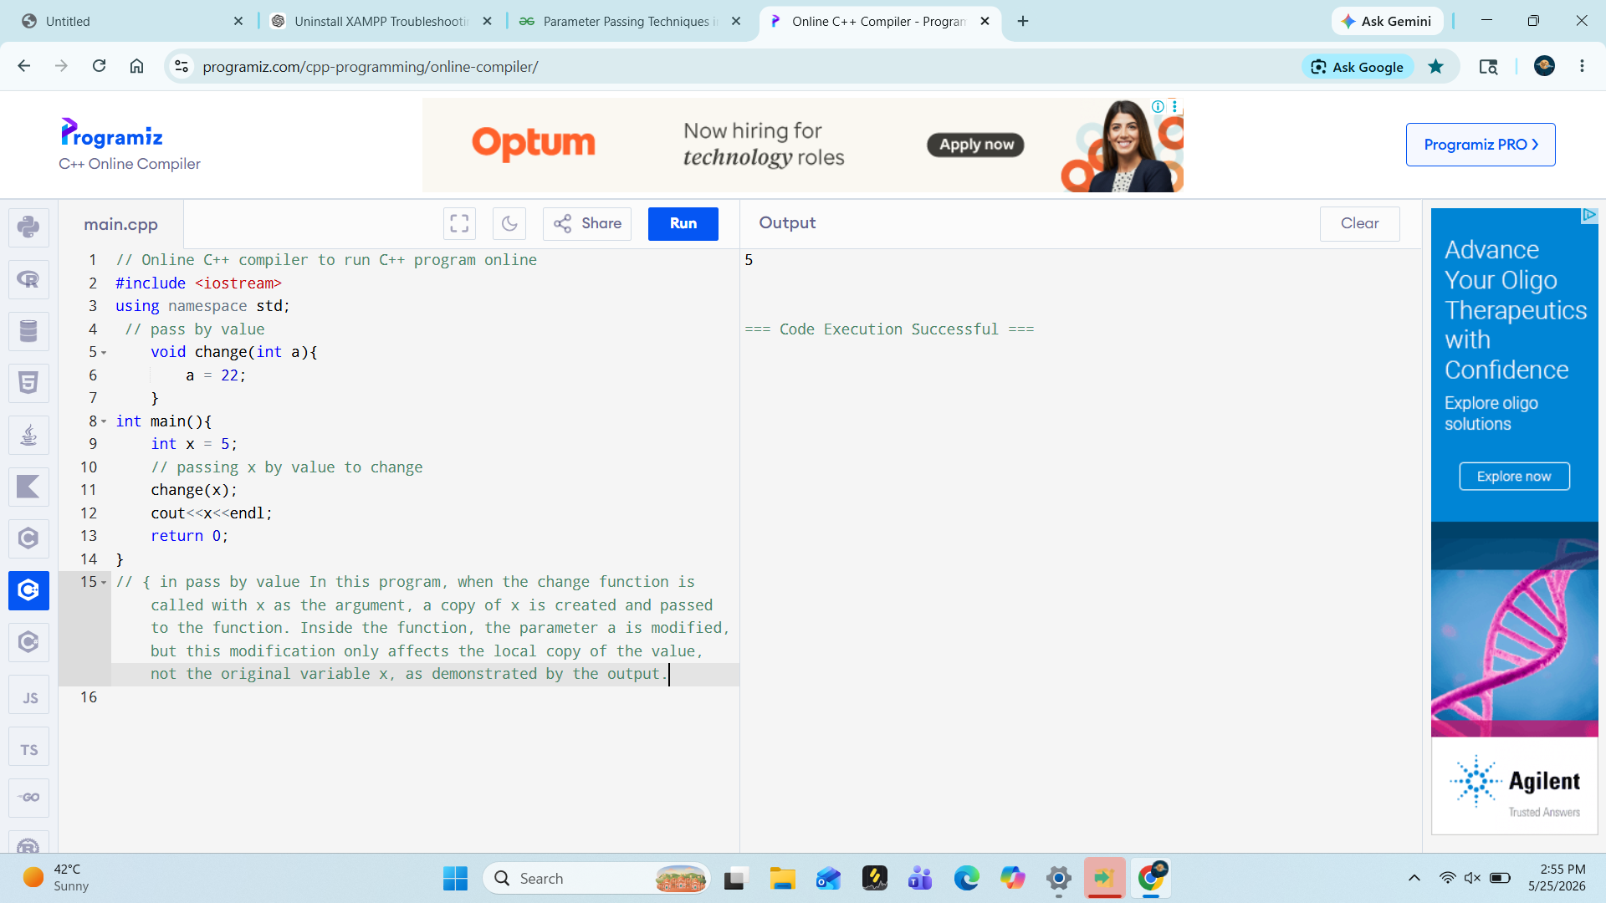

// pass by reference
#include <iostream>
using namespace std;

void change(int& a) {

// Modifying arguments
a = 22;
}

int main() {
int x = 5;

// Passing x by reference to change()
change(x);

cout << x;
return 0; // output is22
}
// in this case the origiinal value is change directly

/ / pass by pointer
# include <iostream>
using namespace std;
void change( int *a){
*a = 25;
}
int main(){
int x = 2;
change( &x);
cout<<x;
return 0; // output is25
}
// it is also change original value but not directly first it goes to the address of the variable

Recursion

include<iostream>
using namespace std;

void f(int n)
{
if(n > 0)
{
cout << n << endl;
f(n - 1);
cout << n << endl;
}
}

int main()
{
int n;

cout << "Enter the value of n: ";
cin >> n;

f(n);

return 0;
}
// output is 😌
6
5
4
3
2
1
1
2
3
4
5
6

- Recursive Case: Recursive case is the way in which the recursive call is present in the function.
- Base Condition: The base condition terminates the recursion.
- DEFAULT ARGUMENTS
#include <iostream>
using namespace std;

// Function with default height 'h' argument
double calcArea(double l, double h = 10.0){
return l * h;
}

int main(){
cout << "Area 1: " << calcArea(5) << endl;
cout << "Area 2: " << calcArea(5, 9);
return 0;
}

Output
Area 1: 50
Area 2: 45

Inline function
#inlcude <iostream>
Using namespace std;
Inline int getSum(int a , int b){
Return a+b;
}
Int main(){
Int a , b;
Int a = 5;
int b = 56;
Int result = getSum(a,b)
Cout <<”the sum of a and b is;”<< a6b <<endl;
Return 0;
} // output is 61

LAMBDA function ➖
A lambda function is also known as anonymous function is a small unnamed function defined using of lambda keyword ([]) , it is often used for short and simple operation and can take multiple arguments but can only have one expression.

Lambda expression ➖
[](int a) -> int{return a-1;};

{learn after all concept learn stl and lambda }
STL:-
#include <iostream>
#include<vector>
using namespace std;
int main(){
// declares an empty vector
vector<int>v1 = {1,2,3};
vector<int> v2(3,5);
// print items of v2
for(int x:v2){
cout << x << endl;}
}

// output is:-
555

Inserting elements:-

#include <iostream>
#include <vector>
using namespace std;
int main(){
vector <int> v1 = {1,2,3,4};
// inserting at the last
v1.push_back(5);

// inserting at index 1
v1.insert(v1.begin() +1 , 0);
for(int x: v1){
cout << x << endl;
}

} // output is:_
1
0
2
3
4
5

Access elements:-

#include <iostream>
#include <vector>
using namespace std;
int main(){
vector <int> v1 = {1,2,3,4};
// Accessing using operator[]
cout<<"accessing an element at index no. 2:" << v1[2]<< endl;
// Accessing using at()
cout << "elements at index no. 3:"<<v1.at(3) << endl;

return 0;
}

// output is :- accessing an element at index no. 2:3
elements at index no. 3:4

UPDATE ELEMENTS:-

using namespace std;
int main(){
vector<int> v = {1,2,3,4,5,6};
v[2] = 50;
for ( int x: v){
cout << x << endl ;

}
return 0;

} // output is:-
1
2
50
4
5
6

Find vector size ➖

#include <iostream>
#include <vector>
using namespace std;

int main() {
vector<char> v = {'a', 'c', 'f', 'd', 'z'};

// Finding size
cout << v.size();

return 0;
} // output is:-
5

Traverse Vector:-{going through each element one by one}
#include <iostream>
#include <vector>
using namespace std;
int main(){
vector<char> v = {'a','b','c','d','e'};
// range based loop
for (char i :v){
cout << i << endl;

}
return 0 ;
}

NOTE 👍Use "for (char &x : v)" when you want to modify the elements of the vector.
- Use "for (const char &x : v)" for read-only access, as it avoids copying and improves efficiency.
DELETE ELEMENTS:-
#include <iostream>
#include <vector>
#include <algorithm>
using namespace std;

int main() {
vector<char> v = {'a', 'c', 'f', 'd', 'z'};
// Deleting last element 'z'
v.pop_back();
// Deleting element 'f'(this create a loop in which complier going through each element to search 'f' , if this find then it remove that)
v.erase(find(v.begin() , v.end(), 'f'));
for( int i = 0; i < v.size(); i++){
cout << v[i] << " ";
}
return 0;
}
// output is:-
a c d
VECTOR EMPTY:-
#include <iostream>
#include <vector>
using namespace std;

int main() {
vector<int> v ;
if(v.empty()){
cout<< "vector is empty:" << endl;
}
return 0;
} // output is:-vector is empty:

Multidimensional Vectors
#include <iostream>
#include <vector>
using namespace std;

int main() {
// Declaring and Initializing a 2D vector
vector<vector<int>> matrix = {
{1, 2, 3},
{4, 5, 6},
{7, 8, 9}
};

// Traversing using range-based loop with auto
for (const auto &row : matrix) {
for (const auto &val : row) {
cout << val << " ";
}
cout<<endl;
}
return 0;
}// output is ➖
1 2 3
4 5 6
7 8 9
deque ➖
In this library we can also use pop_front() to remove first element.
front() Returns the first element.
back() - Returns the last element.
empty() - Returns true if deque is empty.

Clear = Removes all elements from deque.
Deque becomes empty after this.
LIST:-

#include <iostream>
#include <list>
using namespace std;

int main() {
list<int> myList;

myList.push_back(10);
myList.push_back(20);
myList.push_front(30);
cout << "List elements:";
for(int n: myList){
cout<< n << endl;
}
return 0;
} // output is:-List elements:30
10
20

Accessing Elements

#include <iostream>
#include <list>
using namespace std;

int main(){
list<int> l = {1, 3, 4, 2, 5};

cout << l.front() << endl;
cout << l.back() << endl;
cout << *next(l.begin(), 2);

return 0;
}{Explanation: "next(l.begin(), 2)" moves the iterator two positions forward from the start of the list and * dereferences it to print the element at index 2 (the third element).
Output is:-// 1,5,4

Updating Elements
#include <iostream>
#include <list>
using namespace std;

int main(){
list<int> l = {1, 3, 4, 2, 5};

l.front() = 11;
auto it = l.begin();
advance(it, 2);

*it = 10;

for (auto i : l)
cout << i << " ";
return 0;
} // 11 3 10 2 5

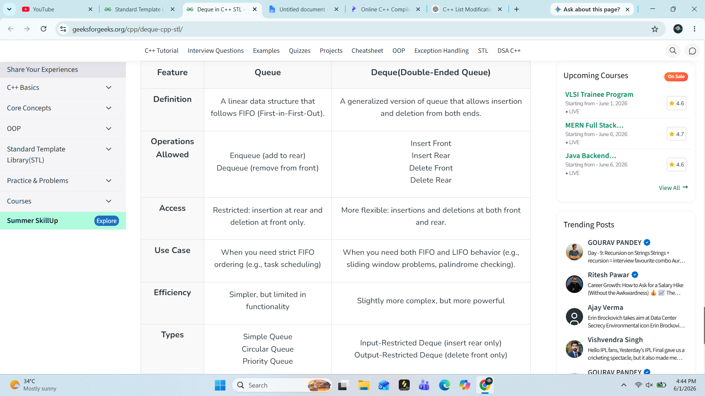

Stack
Its code pattern is same as other function:-
#include <iostream>
#include <stack>
using namespace std;

int main() {
stack<int> st;
st.push(10);
st.push(20);
st.push(30);
st.push(40);

// Deleting top element
st.pop();

while(!st.empty()) {
cout << st.top() << " ";
st.pop();
}
return 0;
} // output is:- 30 20 10

QUEUE:-A queue is a container adapter that stores elements in FIFO (First In, First Out) order. It allows elements to be inserted from the back and removed from the front, ensuring the first inserted element is removed first.
Read other code from love babber sheet
Multiset ➖
#include <iostream>
#include<set>
using namespace std;
int main() {
multiset<int>s = {5,3,3,1,2};
for( auto l: s){
cout<< l << endl;

}
return 0;
} // output 12335

To insert an element ➖
#include <iostream>
#include <set>
using namespace std;

int main()
{
// Creating a multiset of integers
multiset<int> ms;

// Inserting elements (duplicates allowed)
ms.insert(5);
ms.insert(3);
ms.insert(3);
ms.insert(1);

// Print elements (automatically sorted)
for (auto i : ms)
cout << i << " ";

return 0;
} // 1335,4

Finding Elements:-
Multiset provides fast search by value operation using the find() member function. This function returns iterator the element if found, otherwise returns end() iterator.
#include <iostream>
#include<set>
using namespace std;

int main() {
// Write C++ code here
multiset<int> ms = {1,3,2,4,5,6};
auto it = ms.find(3);
if(it != ms.end())
cout<< *it;
else
cout<< " not found!" << " ";

cout<< ms.size()<<endl;
return 0;
} // output 3,6

Deleting Elements: The erase() method removes elements by value (all occurrences) or by iterator (specific element).
#include <iostream>
#include<set>
using namespace std;

int main() {
// Write C++ code here
multiset<int> ms = {1,3,2,4,5,6};
ms.erase(3);
for(auto it:ms){
cout << it<< " ";
}
return 0;
} // output 1 2 4 5 6

Map
Maps are associative containers that store key–value pairs in sorted order .
- Maps do not allow duplicate keys.
#include <iostream>
#include<map>
using namespace std;

int main() {
// Write C++ code here
map<string , int> m1 = {{"geeks" , 1}, {"for" , 2 },{"sus" , 6}};
for(auto& p : m1){
cout << p.first << " " << p.second << endl;

}
return 0;
} // for 2
geeks 1
sus 6

Inserting Elements
#include <iostream>
#include<map>
using namespace std;

int main() {
// Write C++ code here
map<string , int> m1 = {{"geeks" , 1}, {"for" , 2 },{"sus" , 6}};
m1.insert({"mona", 8});
for(auto& p : m1){
cout << p.first << " " << p.second << endl;

}
return 0;
} // for 2
geeks 1
mona 8
sus 6

Accessing elements:

#include <iostream>
#include<iterator>
#include<set>
using namespace std;
int main() {
multiset<int> ms = {1,2,3,45,6};
// Access first element
auto it1 = ms.begin();
cout<< *it1<< " ";

// Access third element we can not direct acess any element from set , multiset, we need iterator
auto it2 = next(it1,2);
cout<< *it2;
return 0;
} // output is:- 1,3

Multimap:-
Multimap is an associative container similar to map, but it can have multiple elements with same keys. It stores all the elements in increasing order based on their keys by default but can be changed if required

#include <iostream>
#include<bits/stdc++.h>
using namespace std;

int main() {
multimap<string,int> mm1 = {{"greek", 1},{"mona", 2},{"sona", 3}};
for(auto it: mm1)
cout<< it.first << ";"<< it.second;
return 0;

} // greek;1mona;2sona;3

1. Inserting Elements :A key-value pair can be inserted into multimap using insert() method. Insertion using [] operator

int main() {
multimap<string , int> mm;
mm.insert({"geeks" , 1});
mm.insert({"moona" , 2});
mm.insert({"trres",5});
for(auto x : mm)
cout << x.first << ";" << x.second << endl;
return 0;
} // output is :- geeks;1
moona;2
Trres;5

Accessing Elements:-
multimap<int, string> mm = {{1, "Geeks"}, {2, "For"}, {1, "C++"}};

// Accessing 1st element
auto f = mm.begin();
cout << f->first << ": " << f->second<< endl;

// Accessing 2nd element
auto it = next(f, 1);
cout << it->first << ": " << it->second;

return 0;
} // output is:1: Geeks 1: C++

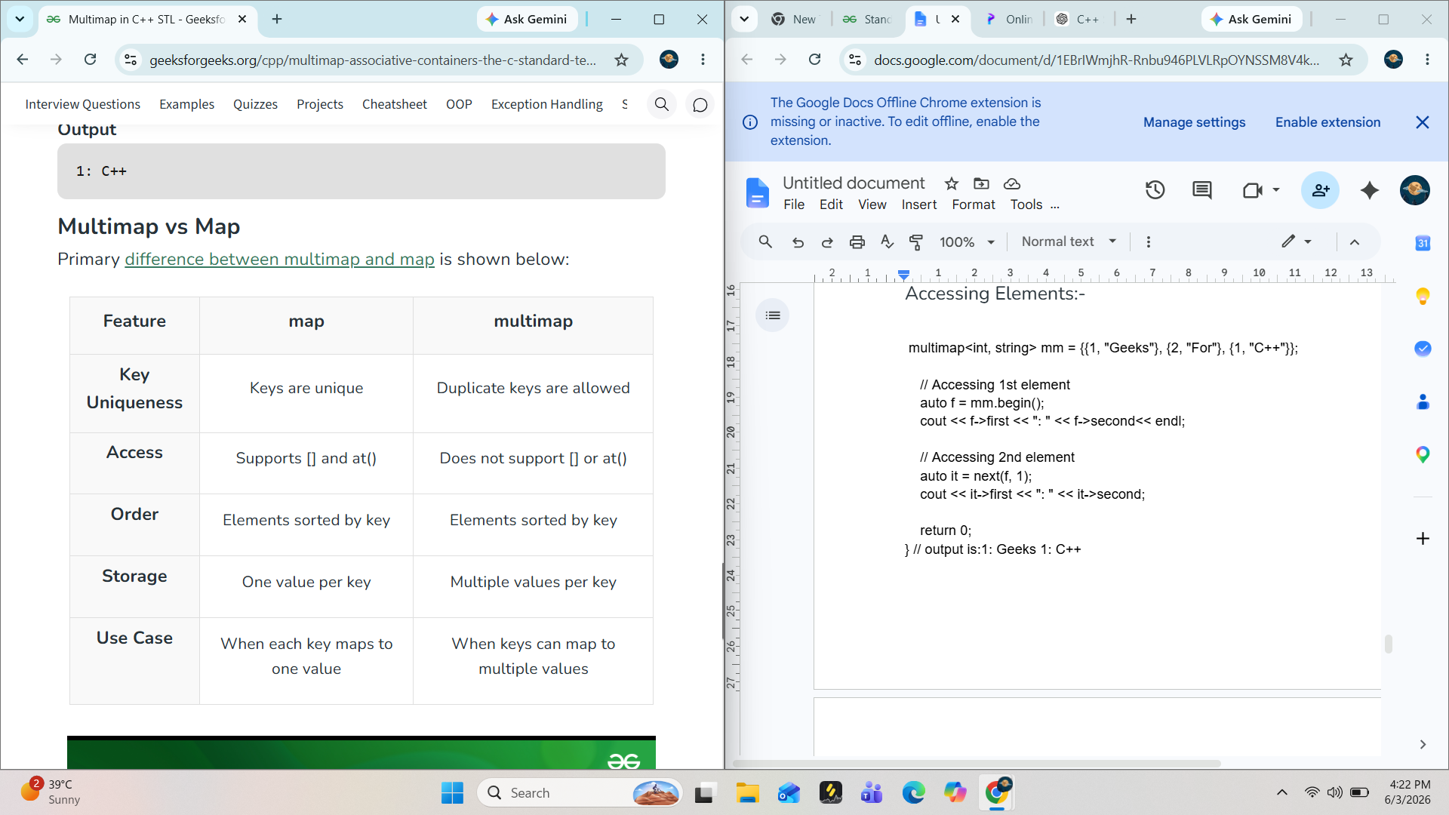

Other fun is same as multi map

Updating Elements: In multimap, the key of any element cannot be modified. But we can modify the value using the iterator to that element.
#include <bits/stdc++.h>
using namespace std;

int main() {
multimap<int, string> mm = {{1, "Geeks"}, {2, "For"}, {1, "C++"}};

// Updating 2nd element value
auto it = next(mm.begin() , 1);
it->second = "java";

for(auto x : mm)
cout<< x.first << ";" << x.second << endl;
return 0;
} // output :1;Geeks
1;java
2;For

Traversing:-

Arrays:-

#include <iostream>
using namespace std;

int main() {
// declaring and initializing an array of size 5
int arr[5] = {2, 4, 8, 12, 16};

// printing array elements
for (int i = 0; i < 5; i++) {
cout << arr[i] << " ";
}

return 0;
}
Output is:-
2,4,8,12,16

Initialize the array =
Int arr[5]= {2,4,8,10,12}

To traverse an array means to visit and access each element of the array one by one.

#include <iostream>
using namespace std;

int main() {
int arr[5] = {2, 4, 8, 12, 16};

// Traversing and printing arr
for (int i = 0; i < 5; i++)
cout << arr[i] << " ";

return 0;
}
// output is ➖[2,4,8,12,16]

Size of array:-

#include <iostream>
using namespace std;

int main() {
// declaring and initializing an array of size 5
int arr[5] = {2, 4, 8, 12, 16};

//size of one element of array
cout<< "size of arr[0]:" << sizeof(arr[0])<< endl;

// size of array:

cout << "size of arr;" << sizeof(arr) << endl;

// length of an array;

int n = sizeof(arr)/sizeof(arr[0]);
cout << "length of an array:" << n << endl;

return 0;
}
// output is:-
size of arr[0]:4
size of arr;20
length of an array:5

References in reversing and swapping two numbers
void reverse_dig(int &a, int &b) {
// Add your code here.
int rev1 = 0 , rev2 = 0;
// remove last digit
while (a> 0){
int digit = a % 10;
rev1 = rev1 * 10 + digit;
a = a/10;
}
while ( b > 0){
int digit2 = b % 10;
rev2 = rev2 * 10 + digit2;
b = b / 10;
}
cout << " reverse of first number:" << rev1 << endl;
cout << "reverse of secong number is :" << rev2 << endl;
}
void swap(int &a, int &b) {
int temp;
temp = a;
a = b;
b = temp;}

Note:-1. But in C++ Programming Language, strings stored in character arrays automatically add one extra character:
For example:-
What is the size of the array char arr[] = "geeksforgeeks";?
Output is : 14
2.In C++ , arrays are always passed to functions by pointer, meaning the function receives the memory address of the first element.
pointer arithmetic is used internally.

Important Formula
arr=&arr[0]\text{arr} = \&\text{arr}[0]arr=&arr[0]
And:
arr[i]=∗(arr+i)\text{arr}[i] = *(\text{arr}+i)arr[i]=∗(arr+i)
When you pass an array to a function, the array itself is not copied.
Instead, the function receives:
address of first element\text{address of first element}address of first element
That address behaves like a pointer.
3.arr is a fixed-size array allocated on the stack, while ptr points to a dynamically allocated array on the heap, allowing for greater flexibility and potentially larger size.
4.Array decay refers to the automatic conversion of an array to a pointer to its first element when passed to a function.
5.The push_back() is a member function of std::vector and cannot be used with C-style arrays.
6.std::array is an STL container, whereas C-style arrays are built-in language constructs.
7.*ptr is dereference the pointer to give the value stored at t.
8. We can not add two pointer

This q makes you some understanding:-
#include <iostream>
using namespace std;

int main() {
int arr[2][3] = {{1, 2, 3}, {4, 5, 6}};
cout << arr[1][1];
return 0;
}

//output is:-
means:
- 2 rows
- 3 columns
Array looks like this:

Row | Column 0 | Column 1 | Column 2
0 | 1 | 2 | 3
1 | 4 | 5 | 6
So output will be at [1,1] = 5
Q2. #include <iostream>
using namespace std;

int main() {
int arr[5] = {1, 2, 3, 4, 5};
int* p = arr;
cout << *(p + 2);
return 0;
}
// output is :-
∗(p+2)=p[2]=arr[2]=3

